Arden Medical Centre

Patient Satisfaction Questionnaire 2014

Surgery visits

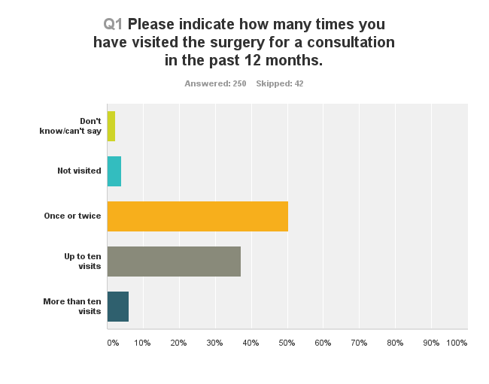

Whilst 50% of the sample had only visited once or twice, 93 patients (37%) had visited up to 10 times and 15 (6%) had visited more than 10 times in the twelve months.

Booking an appointment

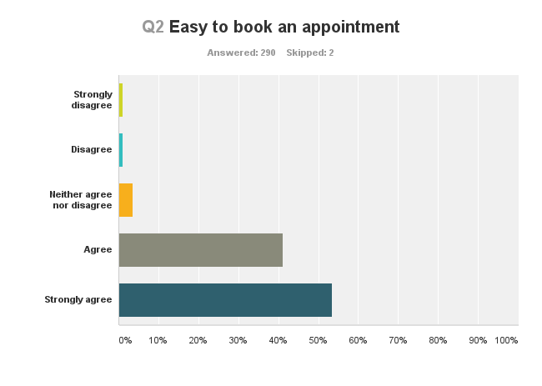

53% of patients surveyed “strongly agreed” that it was easy to book an appointment and a further 41% “agreed”.

Telephone access

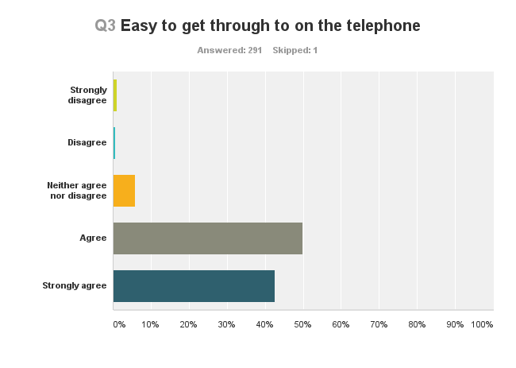

43% of patients “strongly agreed” that it was easy to get through to the surgery on the telephone and a further 50% “agreed”.

Helpful receptionists

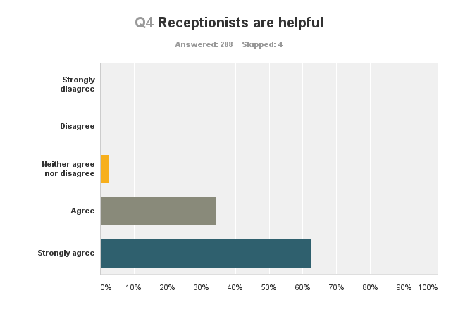

63% of patients “strongly agree” that the receptionists are helpful and a further 34% “agree”.

Appointments at a convenient time

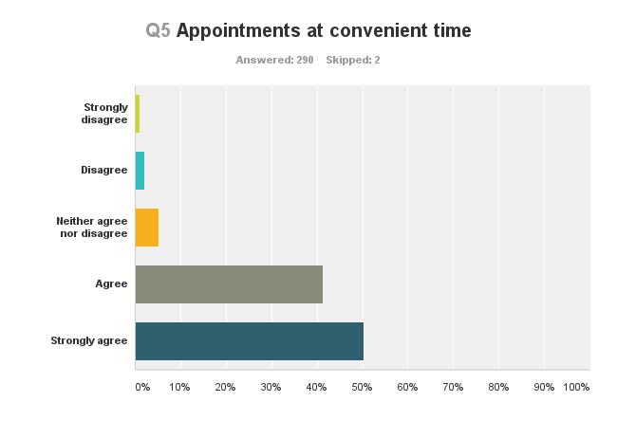

The majority of patients (50%) “strongly agree” that appointments can be made at a convenient time and a further 41% “agree”.

Waiting time at the surgery acceptable
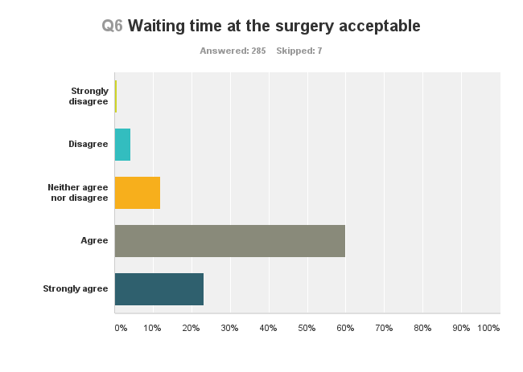

Only 23% of patients “strongly agree” that waiting times at the surgery are acceptable, though 60% “agree”. 48 patients (17%) expressed a degree of dissatisfaction ranging from “neither agree nor disagree” through to “strongly disagree”.
Given enough time with clinician
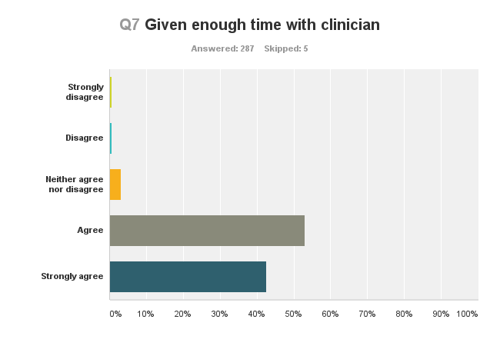

43% of patients “strongly agree” that they are given enough time with their clinician and a further 53% “agree”. Only 4 patients expressed dissatisfaction.

Listened to
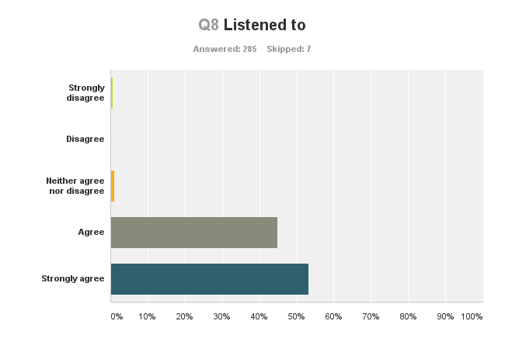

53% of patients “strongly agree” that they are listened to and a further 45% “agree”.

Treatment and tests explained
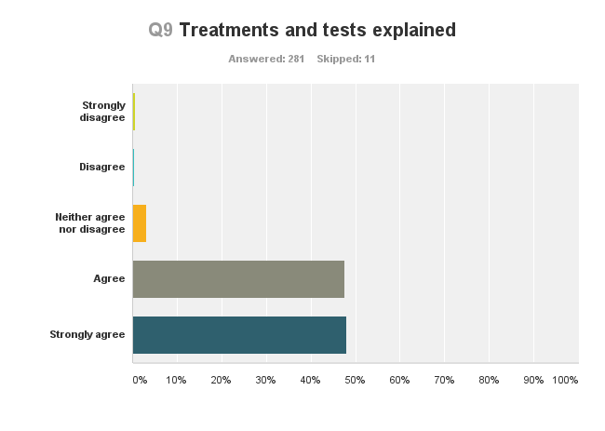

48% of patients “strongly agree” that their treatment and tests are explained and a further 48% “agree”.

Feeling involved with decisions about my care
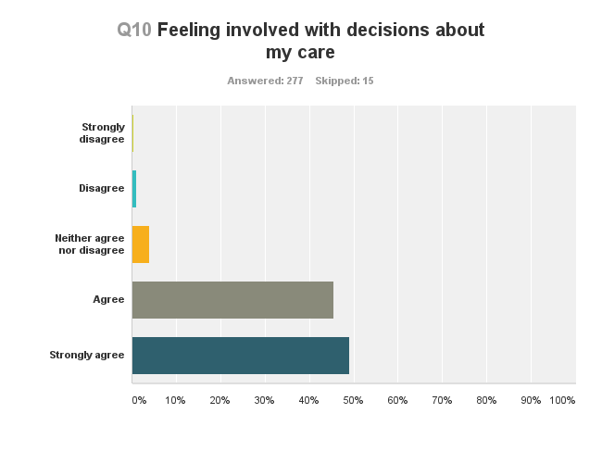

49% of patients “strongly agree” they feel involved in decisions regarding their care and a further 46% “agree”.
Overall I was satisfied with my treatment
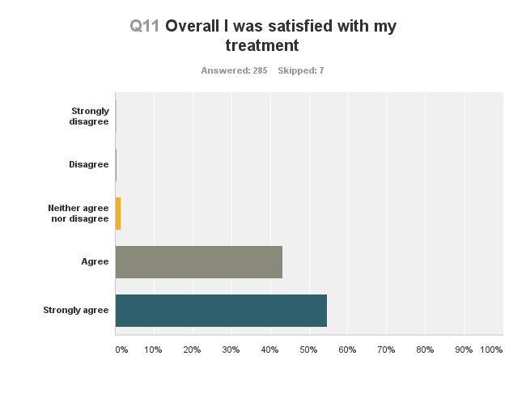

55% of patients “strongly agree” they are satisfied in overall terms with their treatment and a further 43% “agree”.
Aware of practice website
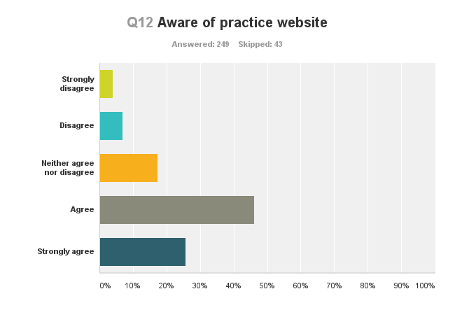

Only 26% of patients “strongly agree” they are aware of the practice website though a further 46% “agree”.
Website is informative

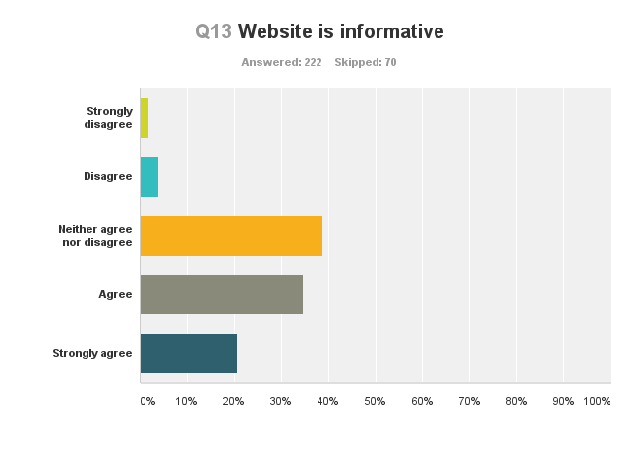
Of the 222 patients who felt able to answer this question 21% of patients “strongly agree” that the website is informative with a further 35% able to “agree”. The majority of patients (39%) felt unable to express an opinion either way.
Use current on line facilities
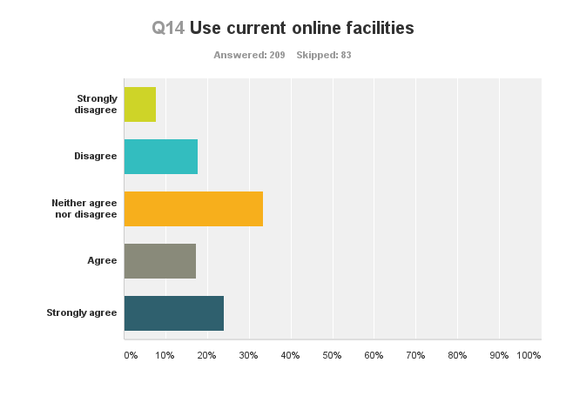

24% “strongly agree” they use the on line facilities and another 17% “agree” for a total of 41%. Therefore the majority of patients are still ambivalent about on line facilities though this is declining with time.

Indicate which on line service you use
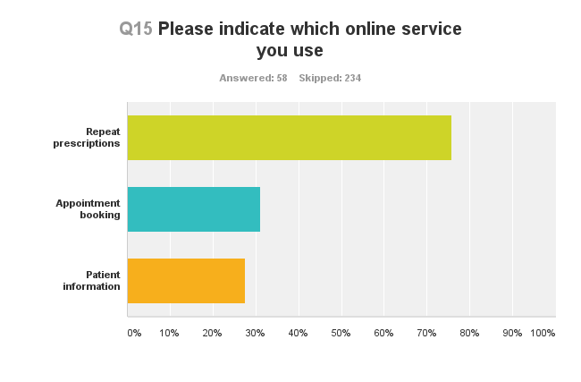
Repeat prescriptions are the dominant factor for the 58 patients who answered this in on line services question. 76% of those patients use this service. 38% use it for appointment booking and 28% for patient information.
Aware of how to raise a concern/complaint
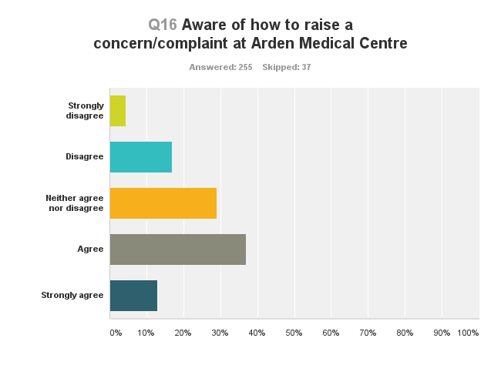

13% of patients “strongly agree” they are aware of how to raise a concern or a complaint and another 37% “agree” – a total of 50%. 20% “disagree or “strongly disagree.”
Overall my experience has been positive
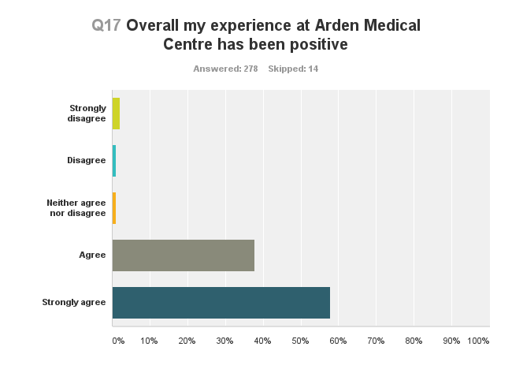
58% of patients “strongly agree” with this statement and a further 38% “agree.” This represents 266 of the 278 patients surveyed. However there are 9 dissenting patients of whom 6 “strongly disagree” with the statement.
Comments or suggestions for improvement
- Sometimes wait times can be lengthy. On occasions some doctors rush through appointments
- Better than the surgery that my wife visits
- Be able to book appointments at least a few days in advance for people who have to book time off work
- Later evening or Saturday appointments would be helpful for me and my husband as we are both work out of the area
and struggle to attend in surgery hours
- Move the practice nearer to Knowle
- I have moved around a lot with my job. Now that I am settled in Dorridge this is the best surgery I have been a patient of.
- Keep up the excellent work
- Not aware of website
- Very helpful all round
- A superb practice with caring doctors & staff
- Think you are all great
- Service excellent
- From my experience the care & service received at Arden medical centre is the best by far!
- Being able to order repeat prescription via pharmacy
- Lovely little surgery. All doctors seen have been extremely friendly & helpful as have receptionists
- Excellent appointment system - never have to wait long for an appointment & often same day. Very impressed
- I haven't looked at website - only to order repeat prescriptions
- Always late going into appointments, never go on time of appointment
- First visit to this practice so can't yet provide some answers
- If I tick the box on prescription form to say that I wish to collect my prescription myself it still goes to Windridges
which is not the chemist I like to use. Also, sometimes the quantities of items are reduced
- Didn't know there was a website
- Improve awareness of website. Open later in evening or a Wednesday afternoon. Saturday morning opening very helpful
- Don't know how to raise concern but then again I've had no need to
- I think you are all great, but sometimes you have to wait for the service in the waiting room. You could have a TV
with subtitles whilst waiting
- Sometimes prescriptions are not sent to Windridges on time, so would appreciate if this could be improved
- Informed when treatment is changed
- Service is very good. All staff are friendly
- Standard of GPs excellent. Ease of getting a convenient appointment - very difficult
- General appointment times I could make before / after work usually taken
- Satisfied
- Parking can be a problem
- One, the whole receptionists are pleasant and helpful, but sometimes obstructive and unhelpful. Too many part-time
Doctors leads to lack of continuity. Surgery shouldn't shut on Wednesday afternoons
- I would be very happy to use online appointment booking!
- Would be helpful if could book routine appointments several weeks in advance
- We think we are very lucky compared with what we hear from other people about other surgeries
- Arden group is excellent
- Prescriptions to Dorridge pharmacy as well as Knowle
- I hope you continue to be the friendly practice you have always been. Will now look back at website!
- Please don’t change, great to get appointments on same day/next day. I hear very bad stories of other surgeries
in Solihull where it is very difficult to get an appointment
- Very satisfied
- Reception are always helpful - as are doctors
- Wonderful service, feel treated as a patient and not as a number as it were, valued
- Very efficient and good care. One concern re report back, was addressed promptly and effectively
- Best surgery I have ever used
- Excellent Service
- Not enough parking. Blood tests to be taken at surgery and not hospital
- When listening to friends discuss their surgeries it appears Arden is getting things done more efficiently
- Have been with Arden many years. Keep on doing exactly what you always do which is excellent
- It would be great if blood tests were undertaken at the surgery avoiding driving, waiting at hospital and £2.75 parking!
- Blood test on site would be most helpful especially for the more elderly and infirm
- Do not know website address
- Excellent, first class service
- I struggle with online site.
- Would be helpful to be able to email the surgery.
Patient demographics
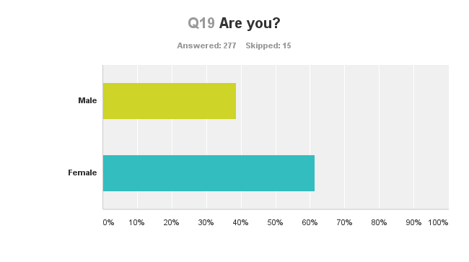

61% of patients surveyed are female and 39% male.

Patient demographics
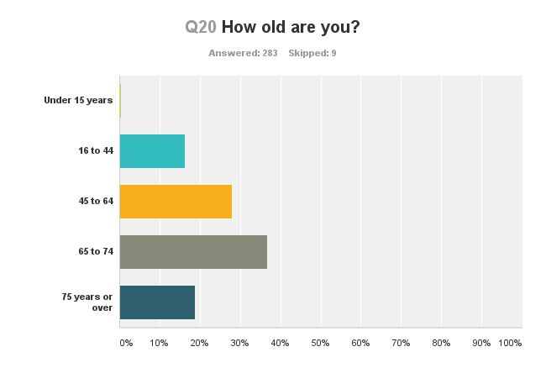

18% of the sample are over 75 years of age and a further 37% are aged 65 to 74 years. Only 16% are below 44 years.

Patient demographics
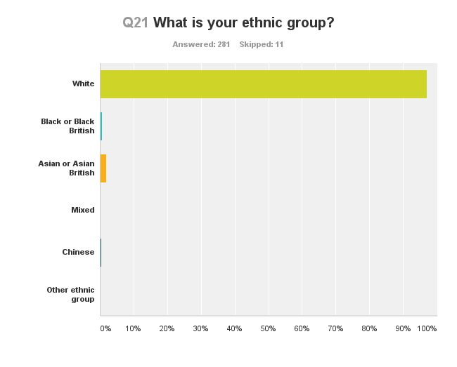
97% of the patients surveyed regard themselves as “white”. Only 7 patients regard themselves as anything else.

Patient demographics
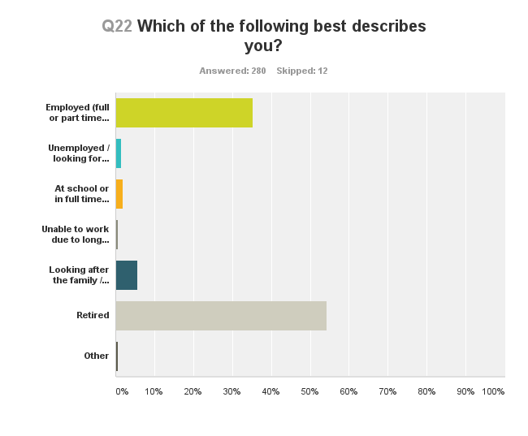

In line with the age profile, the majority of patients (54%) retired.

